FULL STACK DEVELOPMENT

CSA 301

Project: To-do-list
Name: Joseph Carvalho
Roll number:2305111
Class: TYBCA-B
Batch:2

Project Overview

Brief description of the project:
The To-Do List Application is a full-stack project that allows users to register, log in, and manage personal to-do tasks.
Once logged in, users can create, view, edit, and delete their tasks. Each task is linked to the user who created it.
The project demonstrates user authentication, CRUD operations, and frontend-backend integration using modern web technologies.

Technologies Used

• Front-end:
React.js (with Hooks like useState, useEffect)
HTML5, CSS3
Vite (for project setup)
Fetch API (for calling backend APIs)

• Back-end:
Node.js
Express.js (for creating REST APIs)
Bcrypt (for password hashing)
CORS middleware (for frontend-backend communication)

• Database:
MongoDB (via Mongoose ODM)

Code Snippets:
FRONT-END
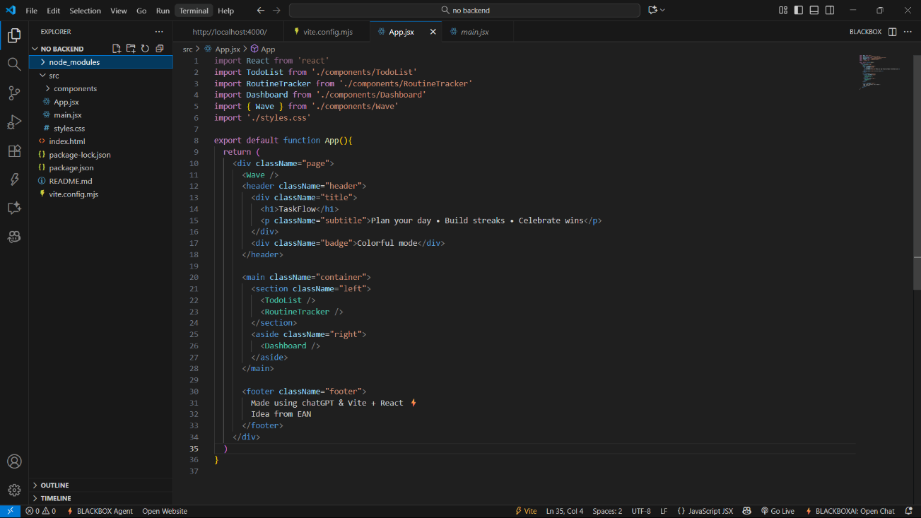

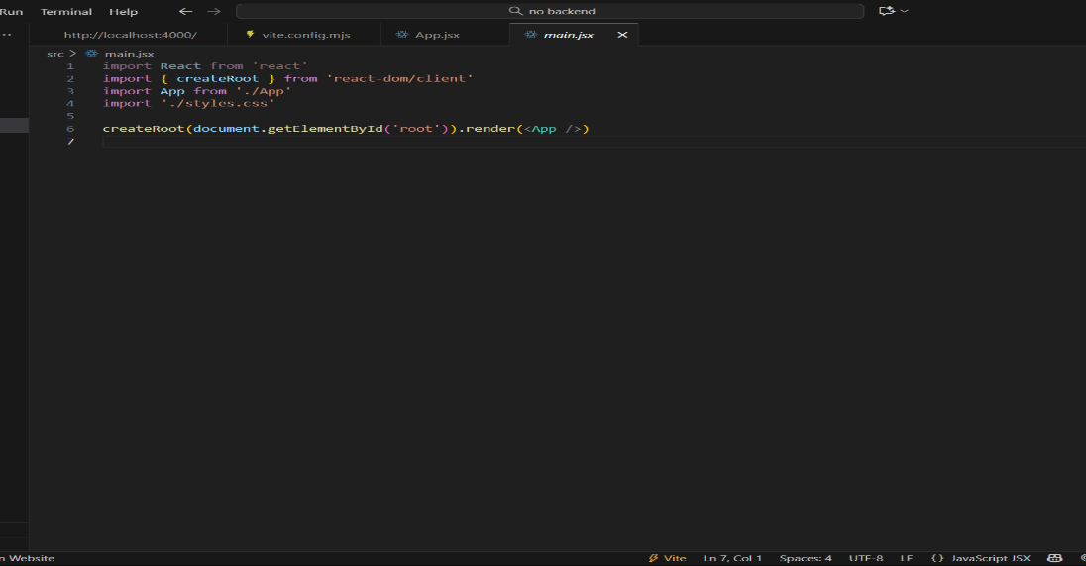

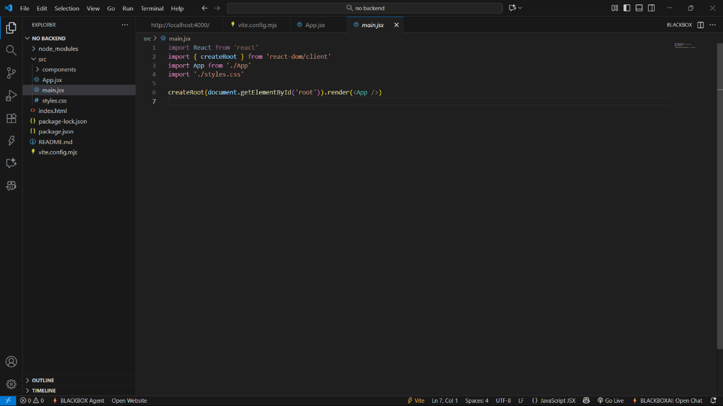

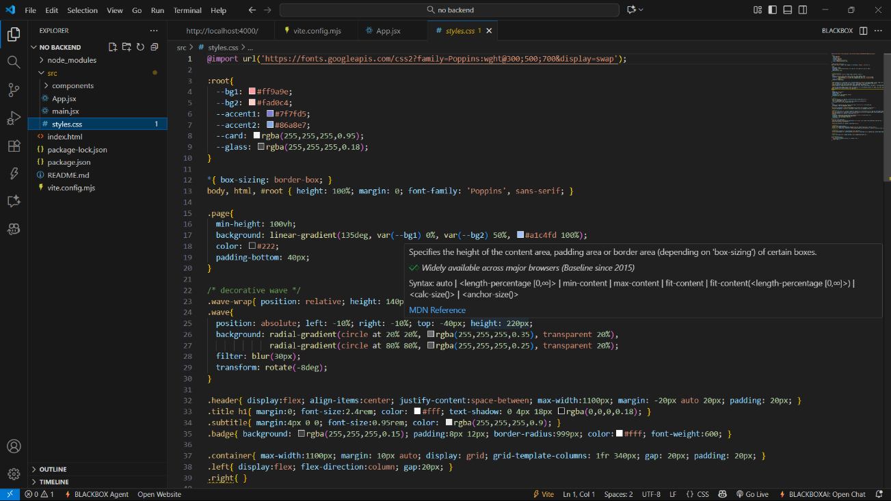

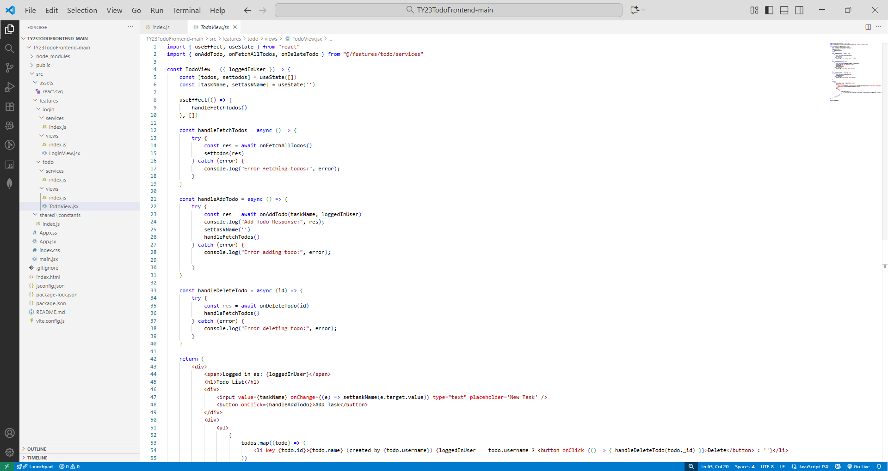

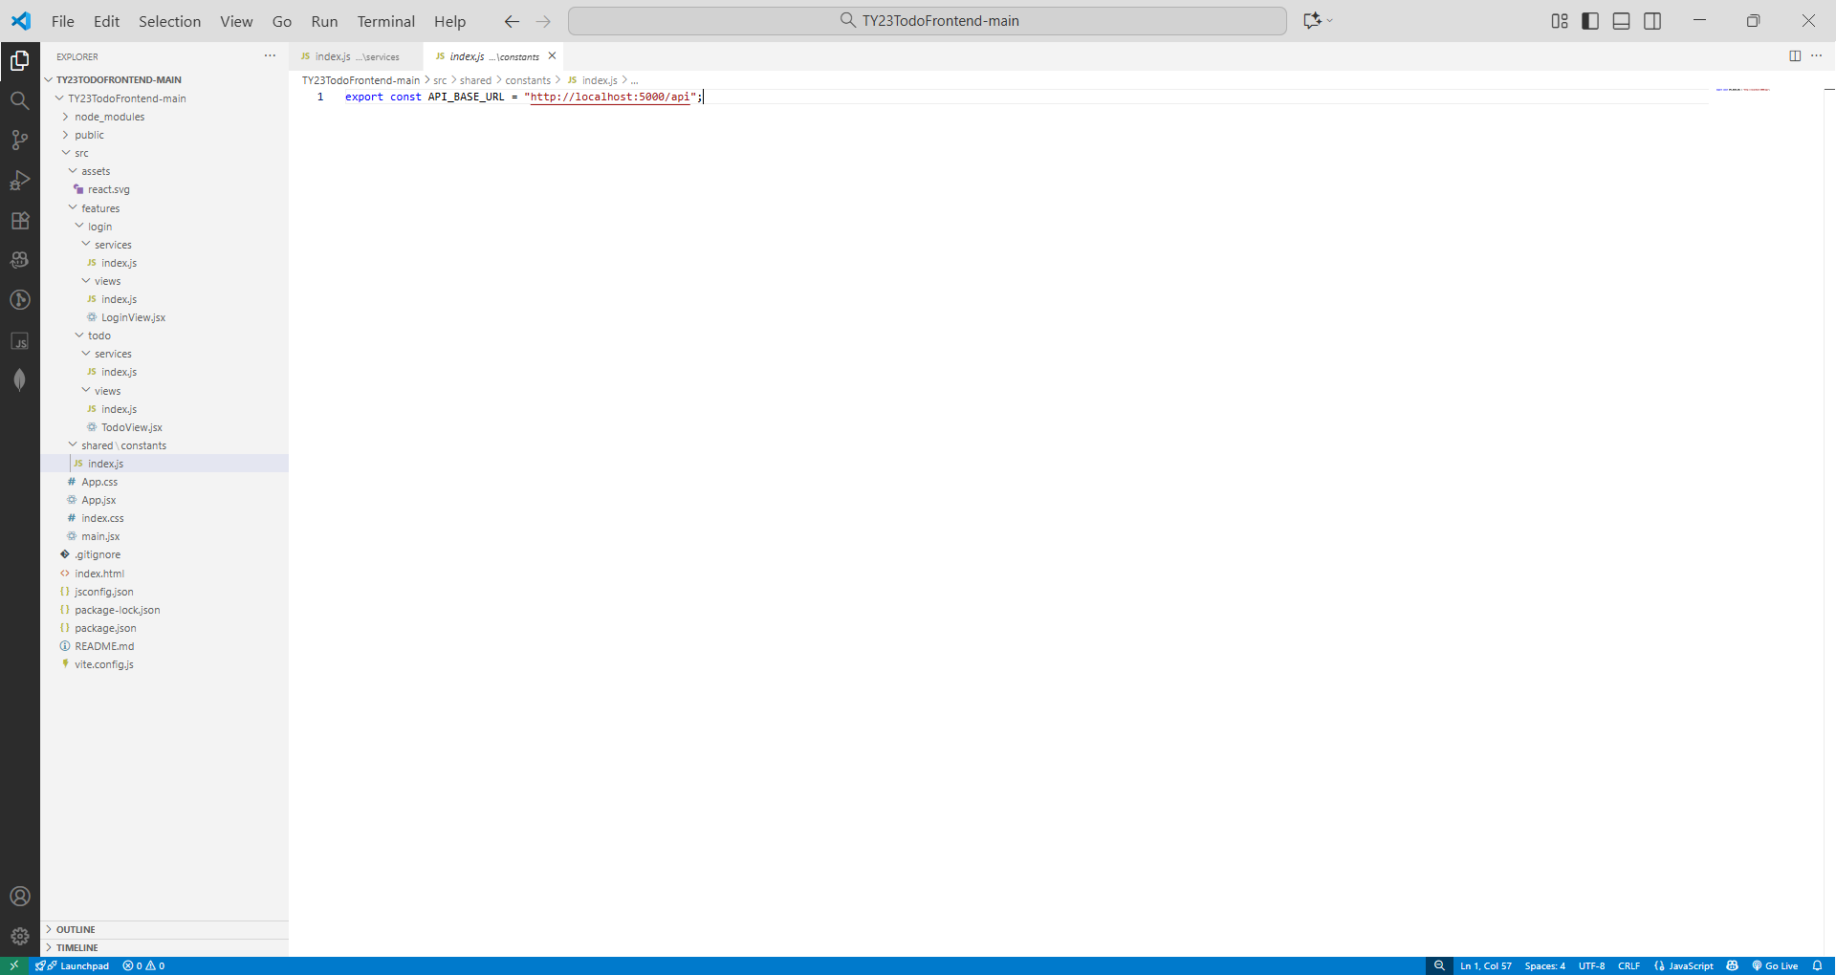

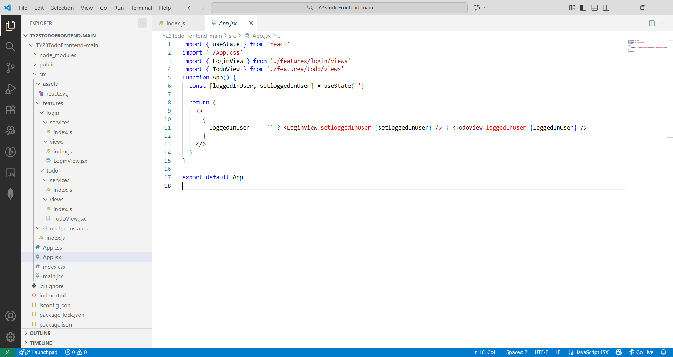

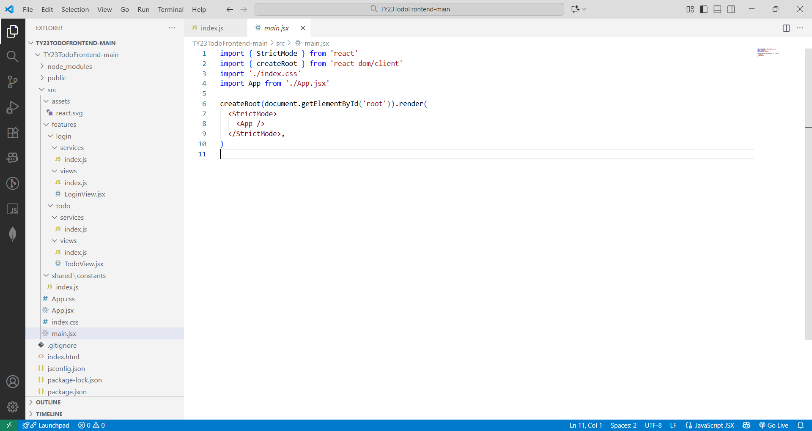

BACK-END
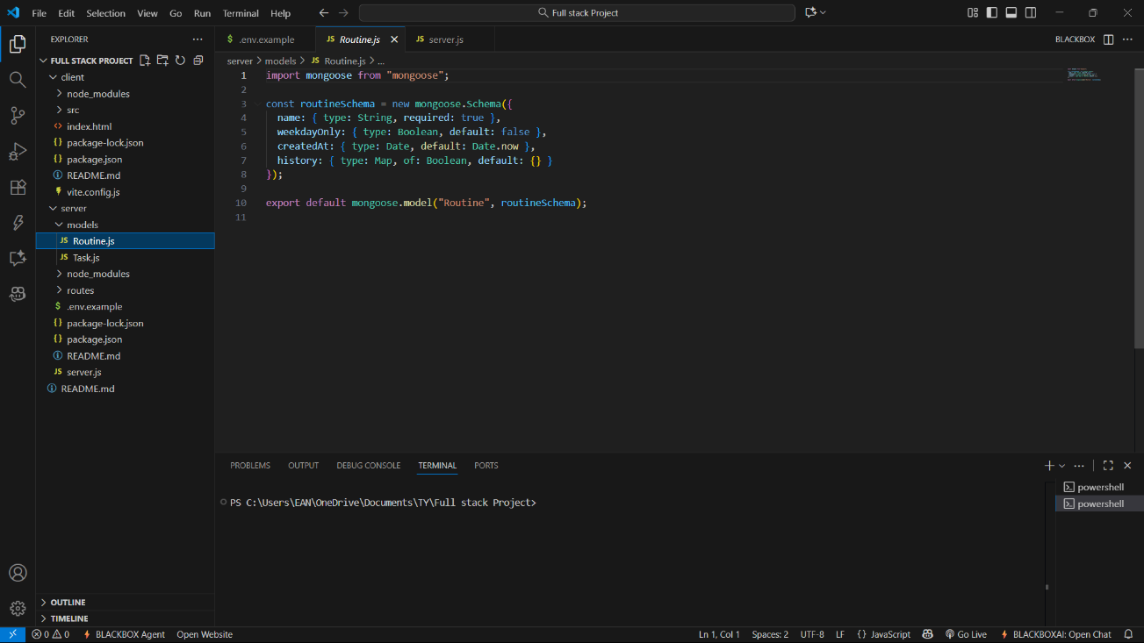

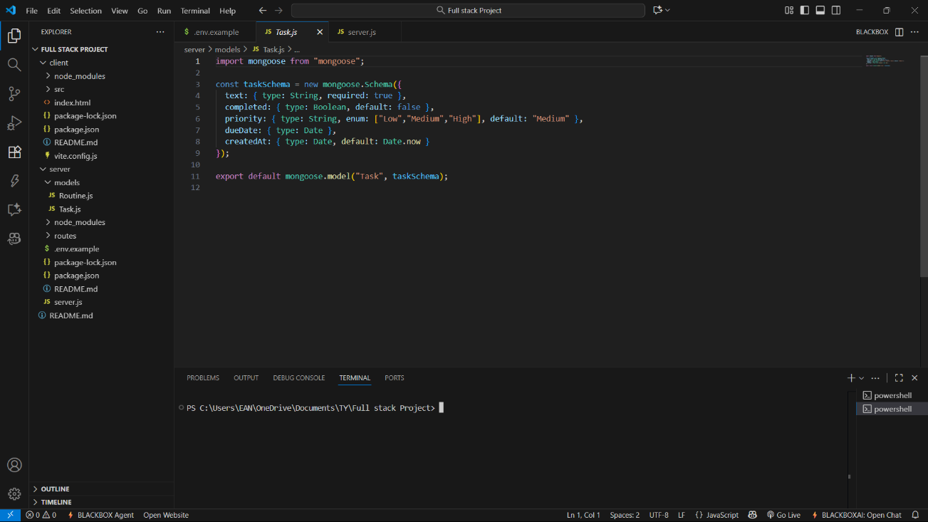

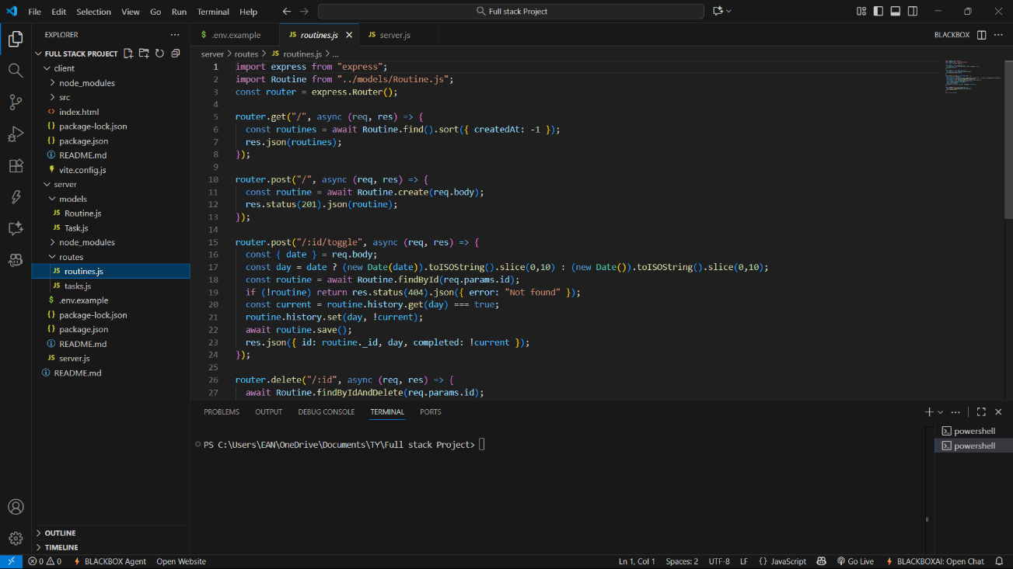

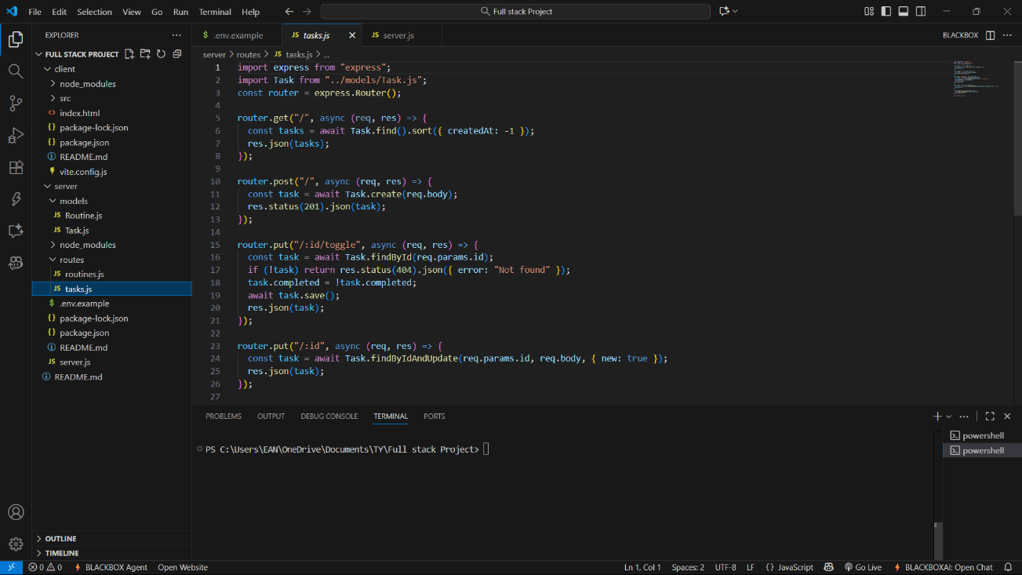

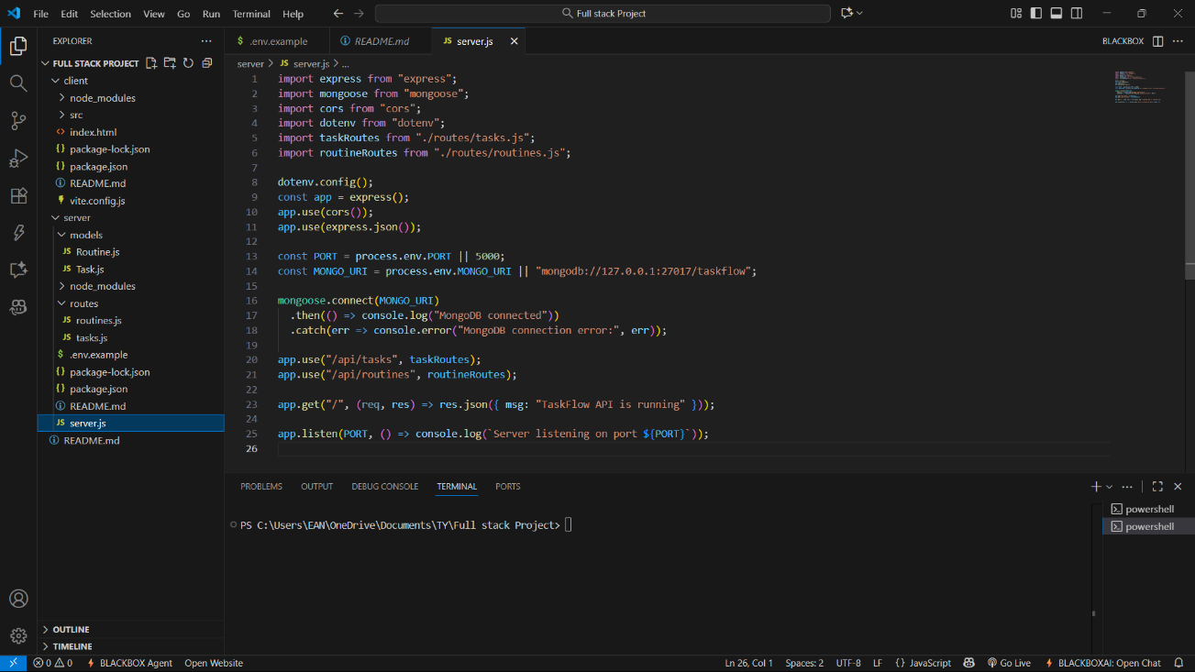

Screenshots:
